PROFILES IBSE Teaching/Learning Materials – Overview
compiled by the PROFILES Working Group of the Freie Universität Berlin – Germany

Berufe-NaWigator – Science-related Occupational Orientation:
“Laboratory Chemist”

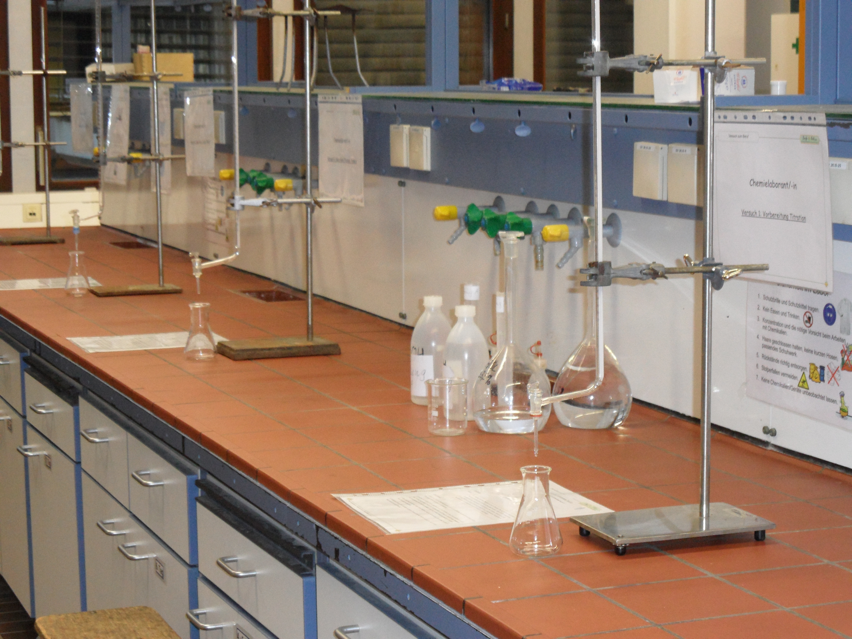
A Module for Science Instruction – especially Chemistry – for Grades 8 / 9

Developed by: Michael Albertus (2012)
Institution: Department of Chemistry Education, Freie Universität Berlin – Germany
Homepage: www.chemie.fu-berlin.de/didaktik - Mail: didaktik@chemie.fu-berlin.de

Abstract
In the module “Laboratory Chemist / Acid-base titration” the students inform themselves of the chemical method of acid and base titration. At the same time the students are introduced into the vocational activities and occupation of a laboratory chemist. The module aims at supporting the students in the process of occupational orientation. This is accomplished in linking chemistry education and selected elements of occupational orientation.
At the end of this module the students are able to practically apply titration in order to find out volume details (the proportion of the base in a base-water-mixture) of two basic solutions with different concentrations of sodium hydroxide.

Subject: Science and/or Chemistry
Grade level: 8th or 9th grade
Curriculum content: Acids and bases, titration, neutralization, occupational orientation.
Kind of activity: Enquiring, explaining, laboratory work, group activities etc.
Anticipated time: 4 lessons of 45 minutes for the example
Overall Objectives/Competencies: Being able to apply the method of acid-base titration and gaining knowledge about the occupational profile of a laboratory chemist.

Attached files
1. | Student activities | Describes the scenario in more detail and the tasks the students should carry out
2. | Teaching guide | Suggests a teaching approach

