PROFILES IBSE Teaching/Learning Materials – Overview
compiled by the PROFILES Working Group of the Freie Universität Berlin – Germany

Berufe-NaWigator – Science-related Occupational Orientation:
“Specialist for Sewage Technology”

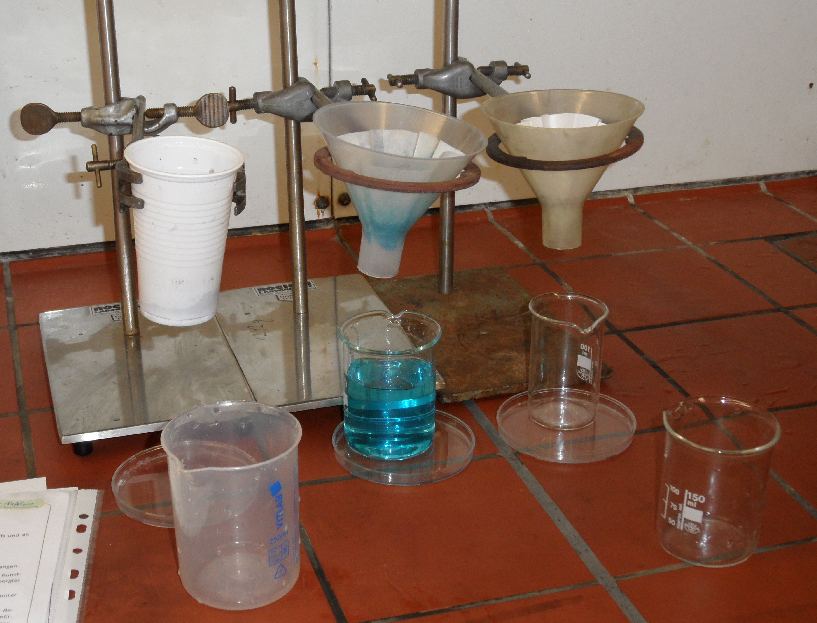

A Module for Science Instruction – especially Chemistry – for Grades 8 / 9

Developed by: Michael Albertus (2012)
Institution: Department of Chemistry Education, Freie Universität Berlin – Germany
Homepage: www.chemie.fu-berlin.de/didaktik - Mail: didaktik@chemie.fu-berlin.de

Abstract
In the module “Specialist for Sewage Technology / Purification of dirty water” the students inform themselves of the separation of mixtures of substances into pure substance components and of the purification of wastewater in sewage treatment plants. At the same time the students are introduced into the occupation of a specialist for sewage technology. This module aims at supporting the students in the process of occupational orientation, linking chemistry education and selected elements of occupational orientation.
At the end of this module, the students are able to practically conduct an exemplary purification of dirty water.

Subject: Science and/or Chemistry
Grade level: 8th or 9th grade
Curriculum content: water, mixtures of substances, properties of substances, filtration,
adsorption, occupational orientation.

Kind of activity: Enquiring, explaining, laboratory work, group activities etc.
Anticipated time: 4 lessons of 45 minutes for the example
Overall Objectives/Competencies: Reconstruction of basic workflows of a specialist for sewage technology. Gaining and applying knowledge and skills regarding cleaning sewage and separating mixtures of substances.

Attached files
1. | Student activities | Describes the scenario in more detail and the tasks the students should carry out
2. | Teaching guide | Suggests a teaching approach

