PROFILES IBSE Teaching/Learning Materials for Students
compiled by the PROFILES Working Group of the Freie Universität Berlin – Germany

Berufe-NaWigator – Science-related Occupational Orientation:
“Specialist for Sewage Technology”

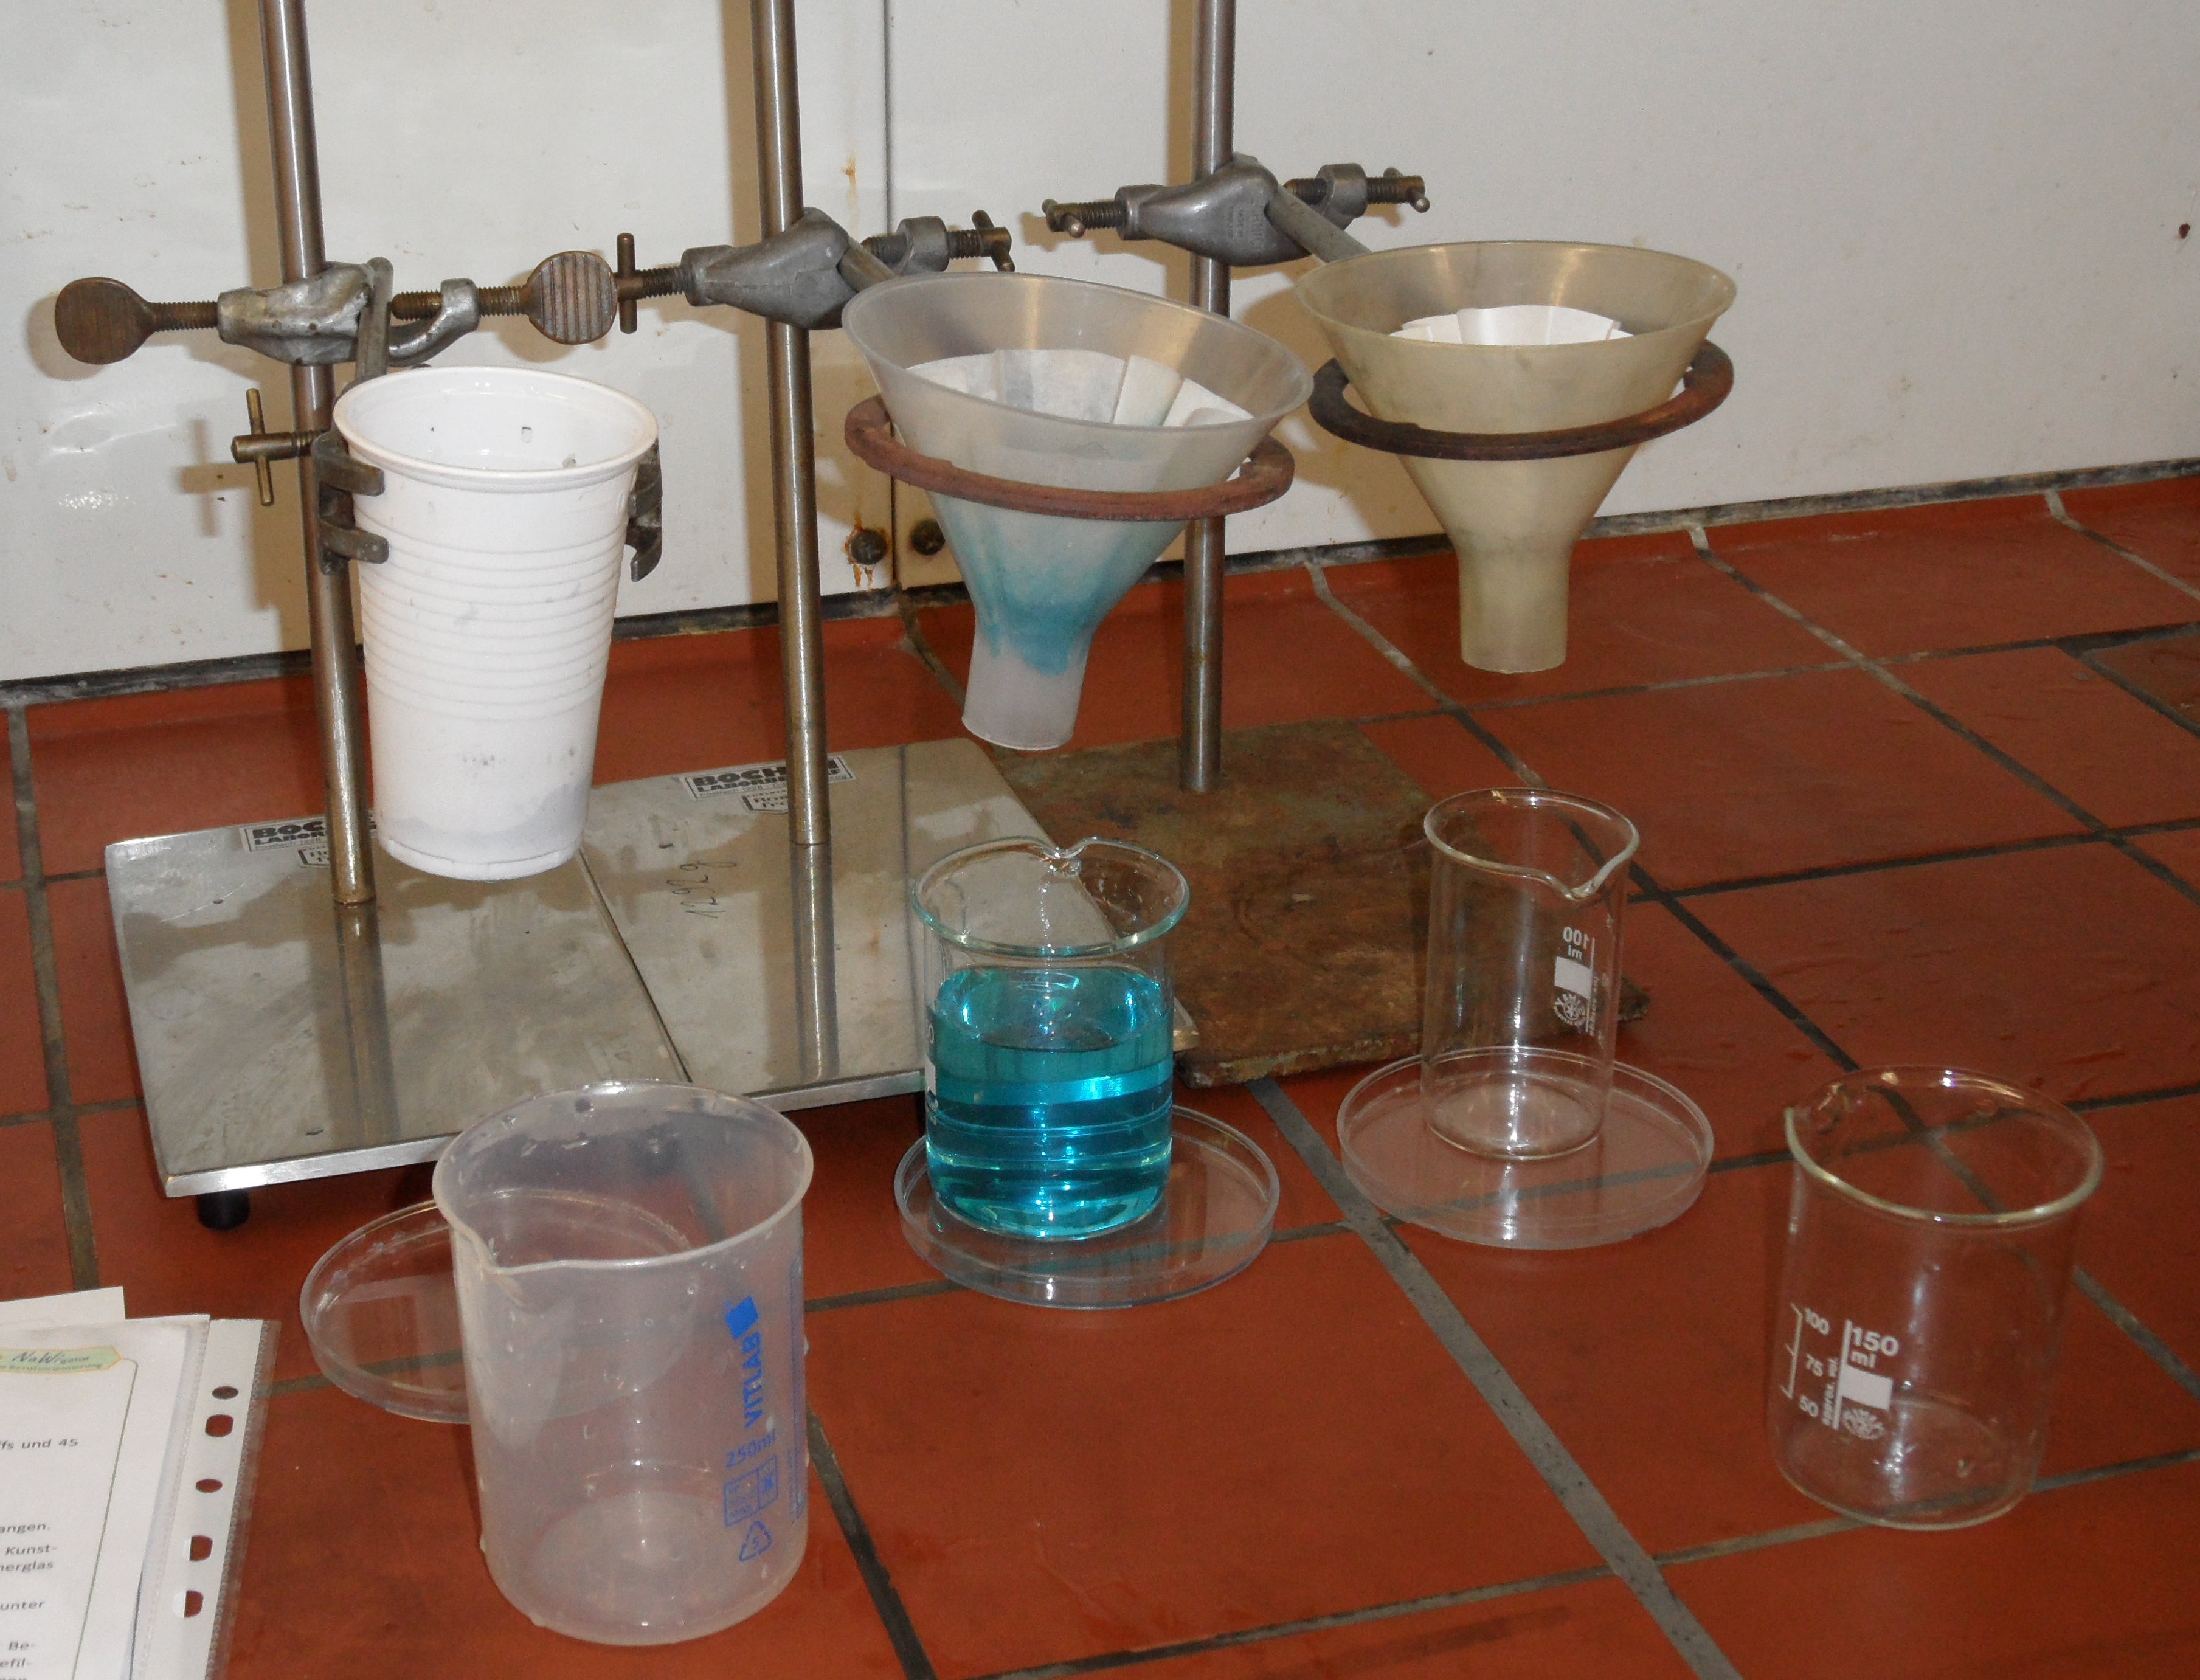

A Module for Science Instruction – especially Chemistry – for Grades 8 / 9

Developed by: Michael Albertus (2012)
Institution: Department of Chemistry Education, Freie Universität Berlin – Germany
Homepage: www.chemie.fu-berlin.de/didaktik - Mail: didaktik@chemie.fu-berlin.de

Outline
How can dirty water be repurified and which tasks does in this context a specialist for sewage technology carry out?
The module “Specialist for Sewage Technology / Purification of dirty water” is dedicated to these and other important questions.
In addition to the conduction of a really interesting student experiment, your skill in research and analysis of information is required. You can find additional information on the occupation of a specialist for sewage technology in the BERUFENET of the Federal Employment Agency (Bundesagentur für Arbeit) (http://berufenet.arbeitsagentur.de/berufe/).

