PROFILES IBSE Teaching/Learning Materials for Teachers
compiled by the PROFILES Working Group of the Freie Universität Berlin – Germany

Berufe-NaWigator – Science-related Occupational Orientation:
“Specialist for Sewage Technology”

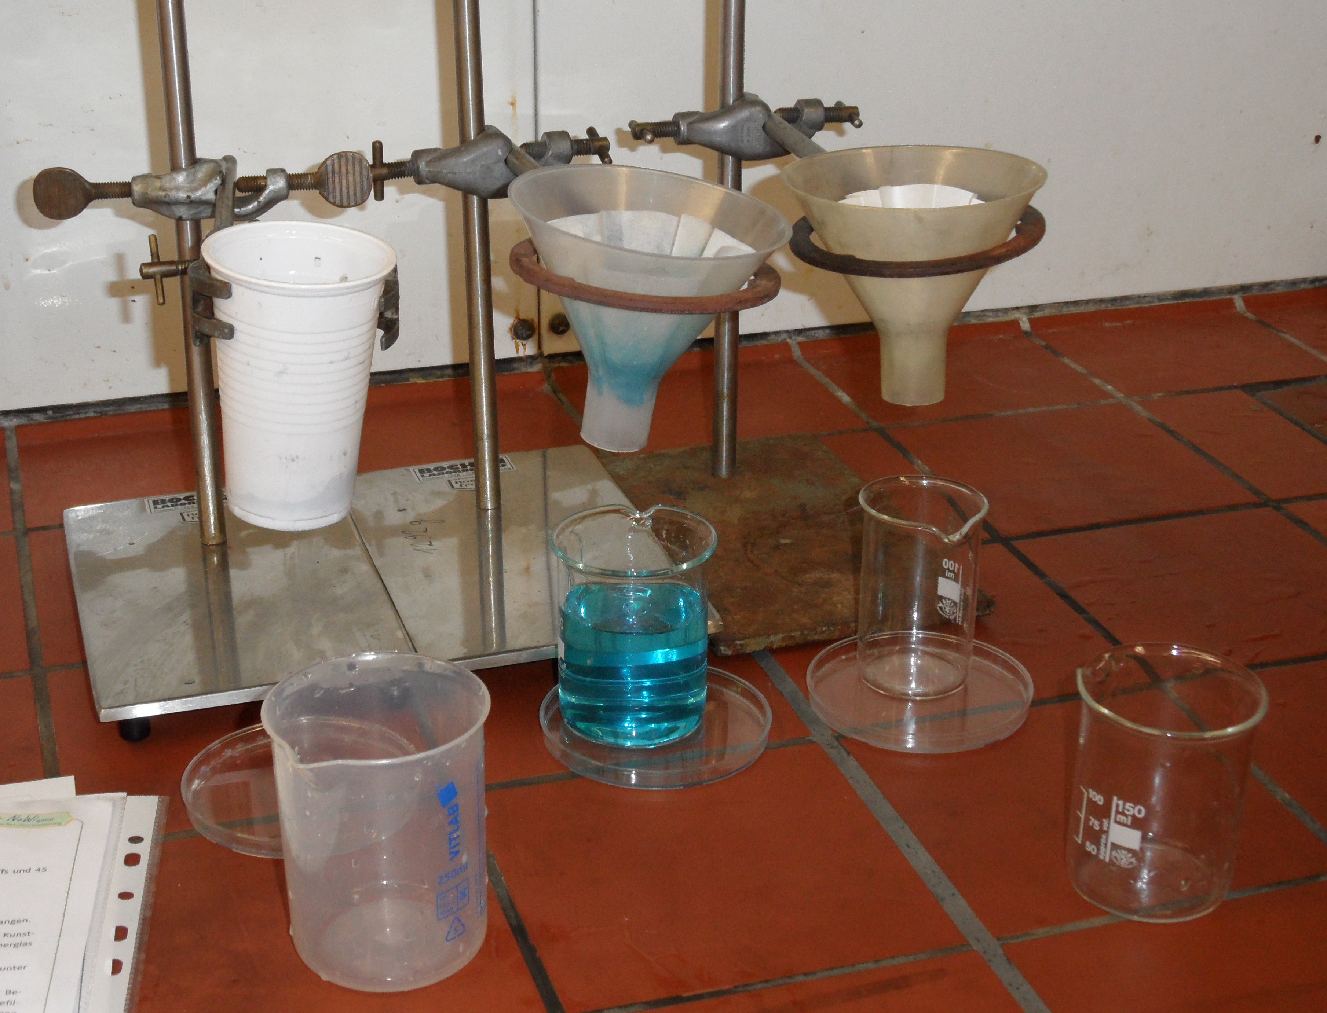
A Module for Science Instruction – especially Chemistry – for Grades 8 / 9

Developed by: Michael Albertus (2012)
Institution: Department of Chemistry Education, Freie Universität Berlin – Germany
Homepage: www.chemie.fu-berlin.de/didaktik - Mail: didaktik@chemie.fu-berlin.de

Module Content
The integration of elements of occupational orientation into chemistry-related learning environments offers another possibility for supporting students in their occupational orientation. For this purpose, information on chemistry-related occupations, selected practical vocational activities and curriculum-based contents are combined.
In the module “Specialist for Sewage Technology / Purification of dirty water”, the occupation of specialists for sewage technology is presented. In a student experiment on the separation of dirty water, the industrial purification of wastewater is illustrated because this activity belongs to the task spectrum of a specialist for sewage technology.
Through the acquirement and application of different processes of material separation (decantation, filtration, separation through adsorption,…), the students can autonomously find possibilities for an optimal cleaning of the self-made substance mixture (dirty water – composition can be varied according to the learning goals). Besides, the student experiment is a good occasion to deal with the functioning of sewage treatment plants and the practical vocational activities of specialists for sewage technology.
In addition to the practical implementation of the student experiments, the students are supposed to practice the protocolling of their assays (according to the level of competence: preparation of at least one protocol with special focus on implementation and observations).
Furthermore, the students can either be provided with various career information from the Federal Employment Agency (Bundesagentur für Arbeit) (films, texts, etc.) or can carry out their own (internet) research. A very helpful resource in this context is the webpage:
http://berufenet.arbeitsagentur.de/berufe/index.jsp
Convenient forms of presentation for the findings obtained are posters, student presentations, or quiz questions developed by the students in the format of the TV-quiz show ‘Who Wants to Be a Millionaire’. Role plays, self-created short films or radio spots on occupations and experiments are also possible.

